UNIT 5
Lesson 8 – AMY SHORT

- 1a) Look at the pictures. Listen, point and say.
Write the words on the empy lines.
Pogledaj slike. Poslušaj, pokaži i izgovori riječi.
Napiši riječi na prazne crte.


PLAY THE GUITAR
(svirati gitaru)
_______________________
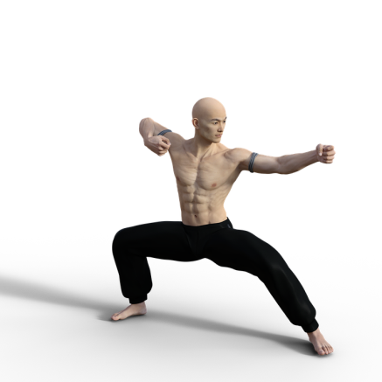
DO KUNG FU

(vježbati / znati kung fu)

_____________________
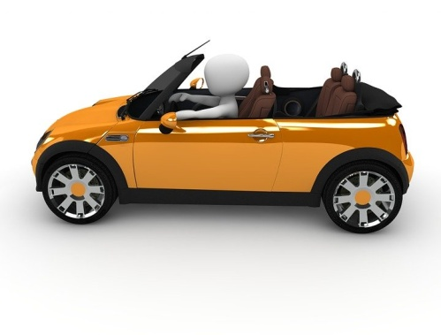
DRIVE (A CAR)
(voziti auto)
_______________________


RIDE (A MOTORBIKE)
(voziti motor)
______________________

- 2 a) Amy Short is a police officer .
She can do a lot of things.
Listen to your teacher read the text.
Amy Short je policajka. Ona zna / može puno stvari.
Poslušaj svog učitelja kako čita tekst.
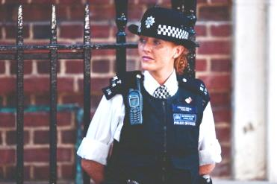

Interviewer: Mrs Short, can I ask you a few questions, please?

Gospođo Short, molim Vas mogu li Vam postaviti nekoliko pitanja?

Mrs Short: Sure.

Svakako.

Interviewer: People talk about you.
They say you're a woman of many talents. Is that true?

Ljudi pričaju o Vama. Kažu da ste vi žena koja ima puno talenata.

Je li istina?

Mrs Short: Well, a wonder woman?
Hmmm. No, I'm not but I can do some things well.

Čudesna žena? Hm. Ne, ali dobra sam u nekim stvarima.
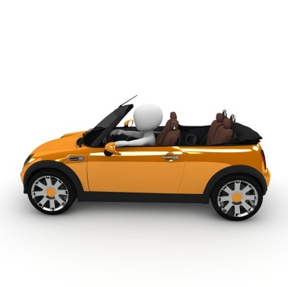

Interviewer: Can you drive a car?

Znate li vozitit auto?

Mrs Short: Yes, I can.


Da, znam.

Interviewer: Can you ride a motorbike?

Znate li voziti motor?

Mrs Short: Yes, I can.

Da, znam.
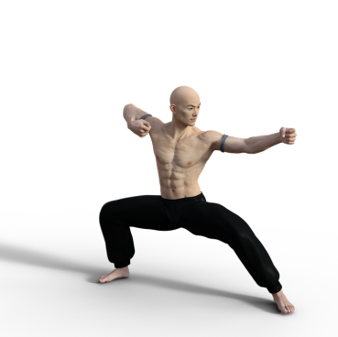

Interviewer: Can you do kung fu?

Znate li kung fu?

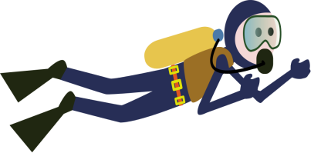

Mrs Short: Of course, I can. I can swim. I can dive , too.

Naravno da znam. Ja znam plivati. Ja znam i roniti.


Interviewer: Can you cook?

Znate li kuhati?

Mrs Short: Yes, I can.

Da, znam.

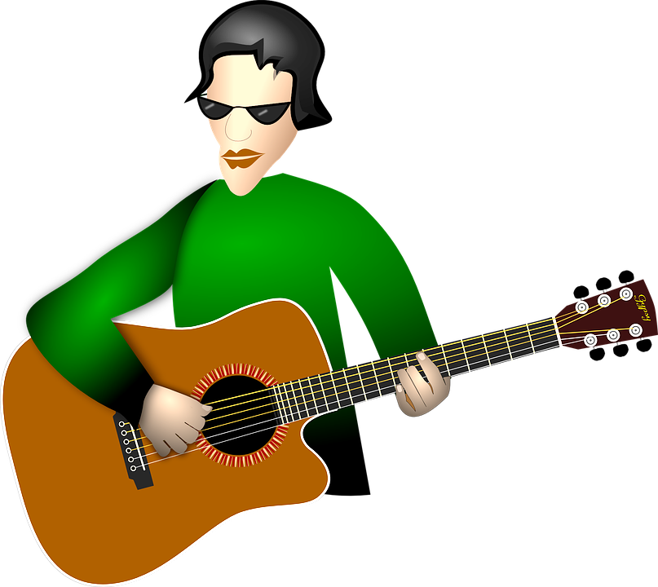

Interviewer: Can you play the guitar?

Znate li svirati gitaru?

Mrs Short: No, I can't.

Ne znam.

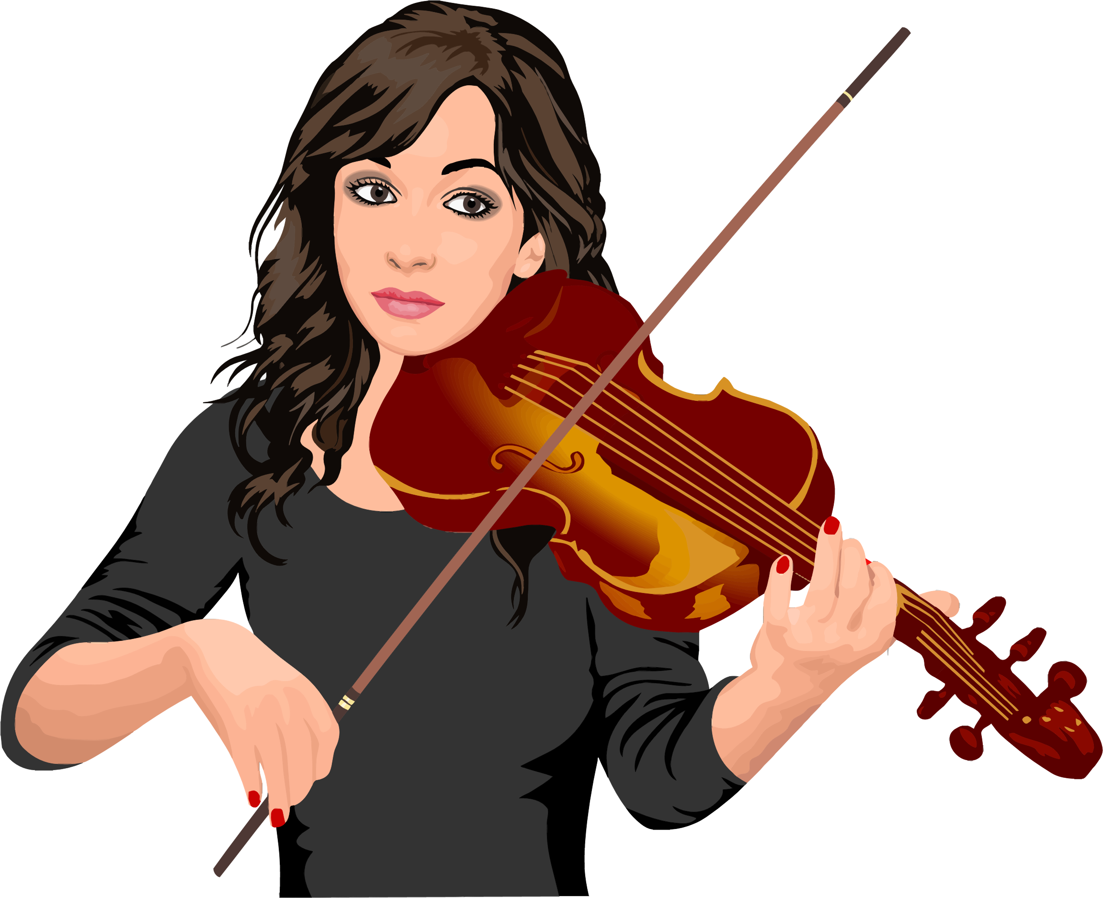

Interviewer: Can you play the violin?

Znate li svirati violinu?

Mrs Short: Yes, I can.

Znam.



Interviewer: Officer Short, can you run very fast?

Policajko Short, možete li trčati jako brzo?

Mrs Short: Sure.

Naravno.


Interviewer: Then catch a thief. Look!

Onda ulovite lopova. Pogledajte!

b) Listen  and read the interview again.
Tick the activities which Amy Short can do.

Go back to the text for help. Check the answers with your teacher. Poslušaj i pročitaj intervju još jednom. Kvačicom označi sličice koje su točne za Amy, opisuju ono što ona zna i može.

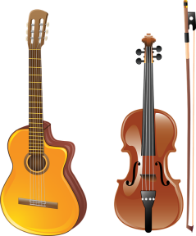 | 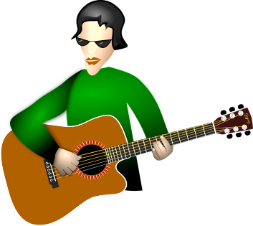 | 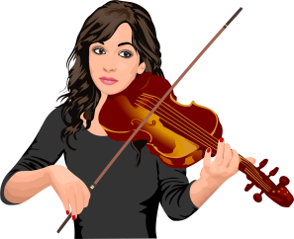



c) Answer the questions. Circle the correct answer.
Odgovori na pitanja o policajki Amy. Zaokruži točne odgovore.

1 Can Amy drive a car?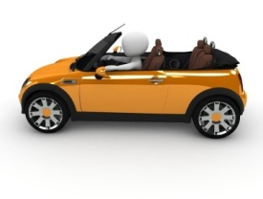 Yes, she can. / No, she can't.

Zna li Amy voziti auto?

2 Can Amy ride a motorbike?  Yes, she can. / No, she can't.

Zna li Amy voziti motor?

3 Can Amy do kung fu? 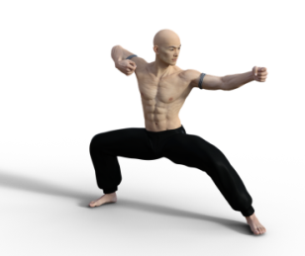 Yes, she can. / No, she can't.

Zna li Amy kung fu?

4 Can Amy swim? Yes, she can. / No, she can't.

Zna li Amy plivati?

5 Can Amy dive? Yes, she can. / No, she can't.

Zna li Amy roniti?

6 Can Amy cook? Yes, she can. / No, she can't.

Zna li Amy kuhati?

7 Can Amy play a musical instrument? 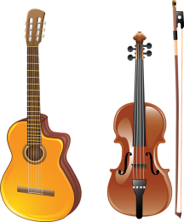

Zna li Amy svirati neki glazbeni instrument?

Yes, she can. / No, she can't.

8 Can Amy play the guitar?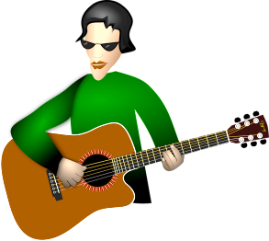 Yes, she can. / No, she can't.

Zna li Amy svirati gitaru?

9 Can Amy play the violin? Yes, she can. / No, she can't.

Zna li Amy svirati violinu?

10 Can Amy run very fast? Yes, she can. / No, she can't.

Zna li Amy jako brzo trčati?

- 3 It is time for your interview. Choose a classmate.
Ask your friend the questions from 1 - 5.
Answer with: Yes he / she can. / No, he / she can't..

Vrijeme je za tvoj intervju. Izaberi prijatelja iz razreda kojeg ćeš intervjuirati.
Pitaj ga / nju pitanja od 1 – 5. Odgovori s: Da, on / ona zna / može. Ne, on / ona ne može.

1 Can you dance ? 

_______________________________________________________

2 Can you sing? 

_______________________________________________________

3 Can you swim? 

_______________________________________________________

4 Can you play a musical instrument?

_______________________________________________________

5 Can you run very fast? 

_______________________________________________________

